Screenshots of Flask Project Pages

1. **Project Structure**

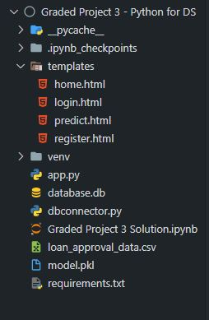

1. **Home Page**

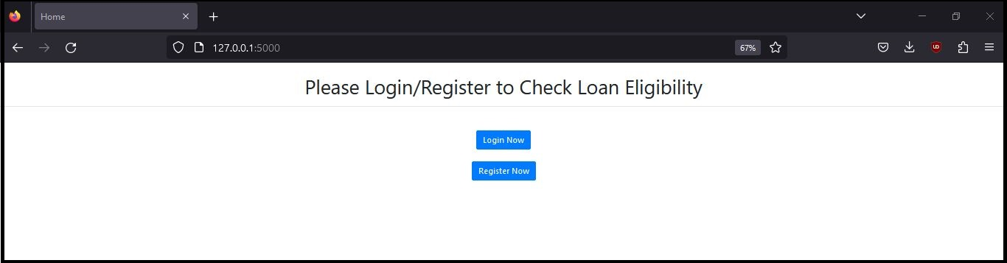

1. **Register Page**

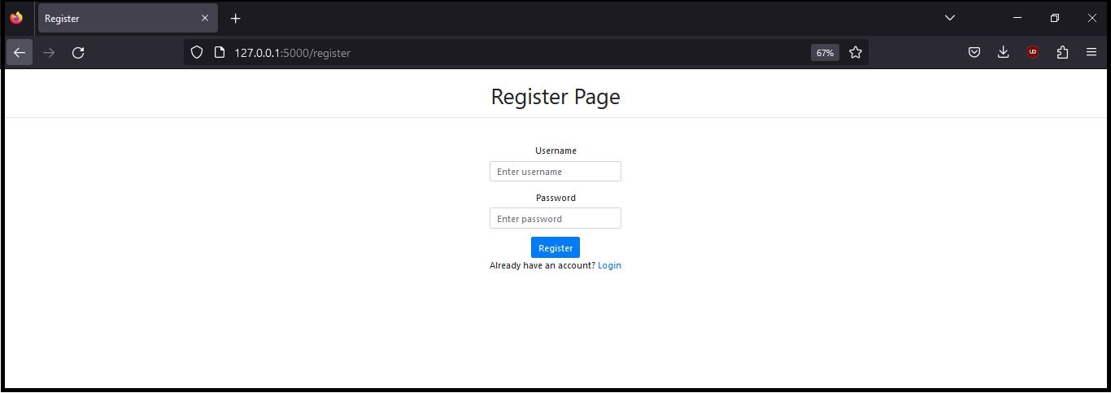

1. **Login Page**

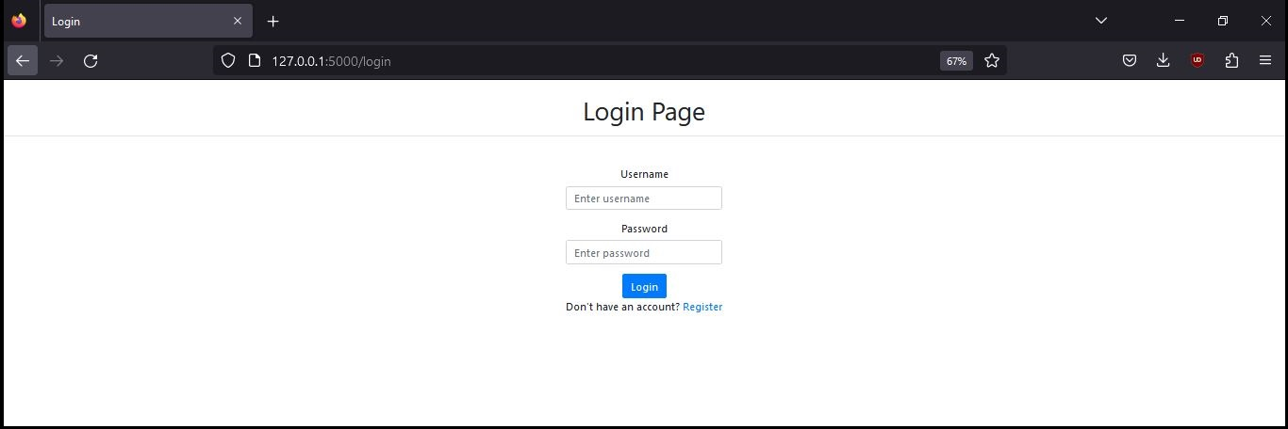

1. **Enter Details Page**

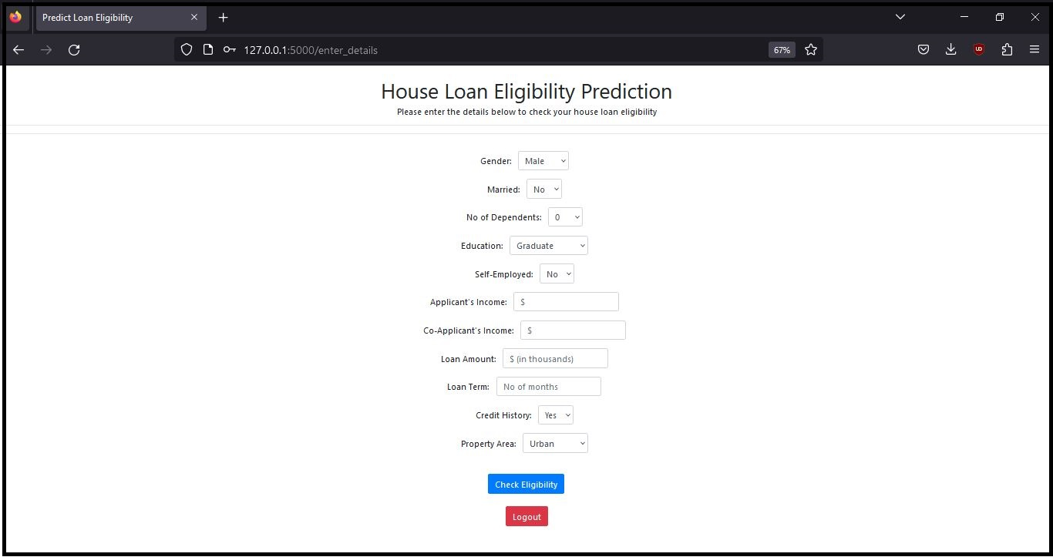

1. **Prediction Page [Eligible]**

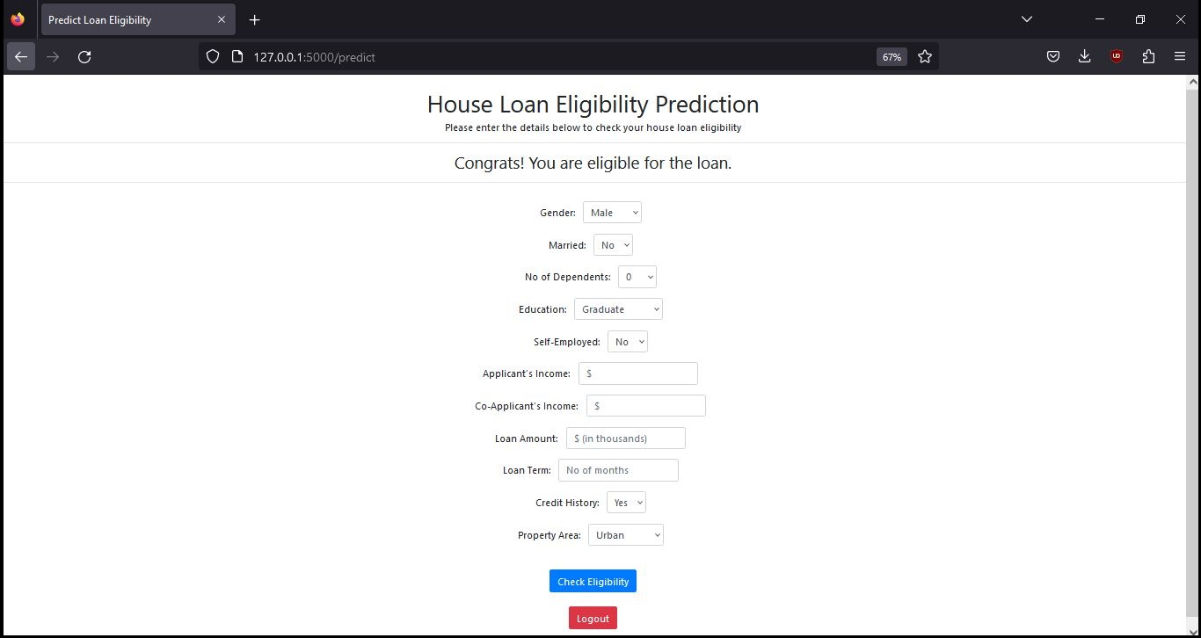

1. **Prediction Page [Not Eligible]**

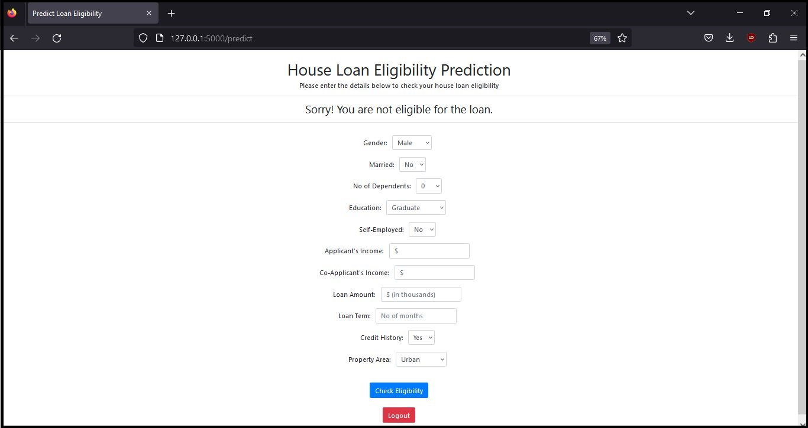

1. **Database Schema Using Sqlite3**

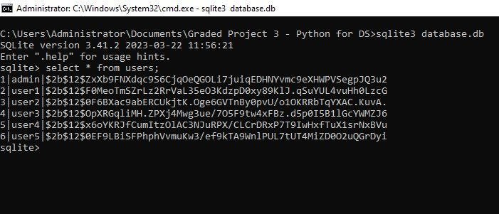

**END OF DOCUMENT**